**Notes (Gather info):**

* Need tiny UI features that add up to the overall experience
  + Back buttons
  + Enter
  + Submit
  + Other buttons that we use that we have taken for granted
  + Improves usability
* Less Cluttered pages
* Seamless Flow of one UI to the next
* Context one:
  + Idea is to get people more informed about current scams
  + Want this attribute to be quite accessible and not hard to find
  + We want to promote this feature even though it is not a core feature
  + Have this option available ie) don't make this a special branch
* Context two:
  + We want people to determine if a point of contact is safe
  + Note that a lot of things are happening in the backend but we need to tell the user whats going on at all times
  + Notify backend processes to the UI for users to see and understand
* Automation of scam detection for text messages and phone calls
  + Includes temporary hiding of scam text/calls and permanent blocking of scam phone numbers.

**Ideas (Doodles):**

* 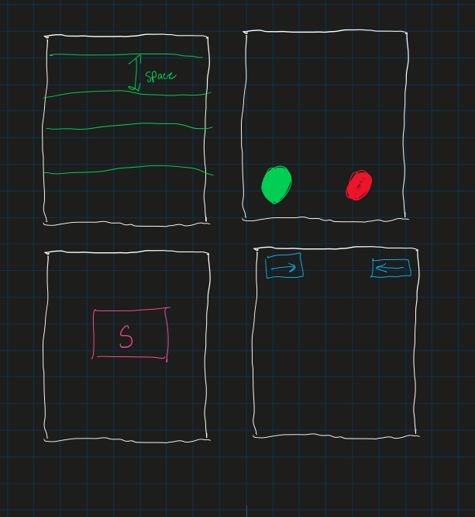
* Basic Attributes
* Context 1 idea branching: We want the option available right away

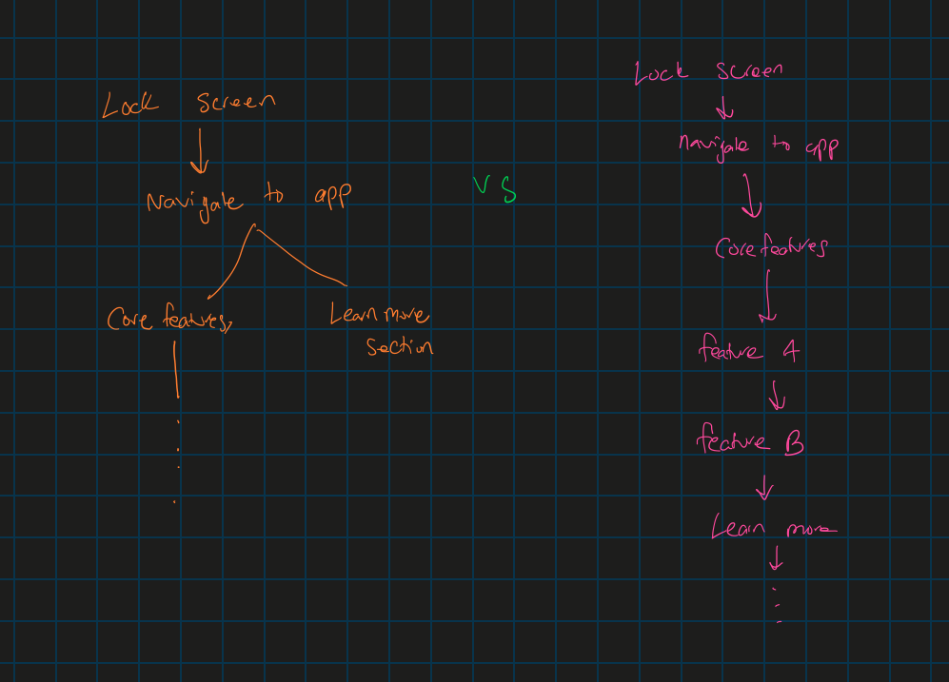

Context 2:

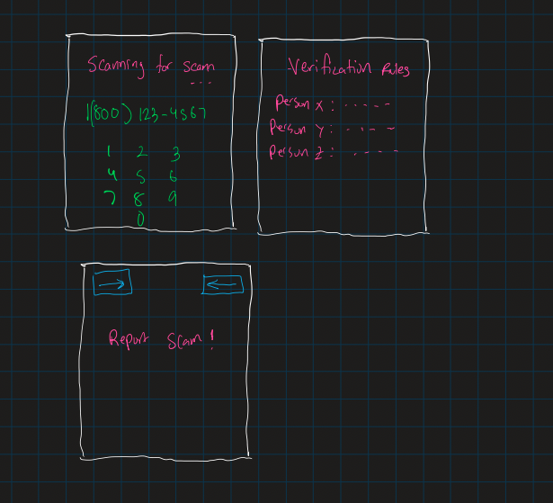

Scanning methods show what happening and indicate that the user may have to execute certain tasks following

Concept 2: Automation of Scam Detection

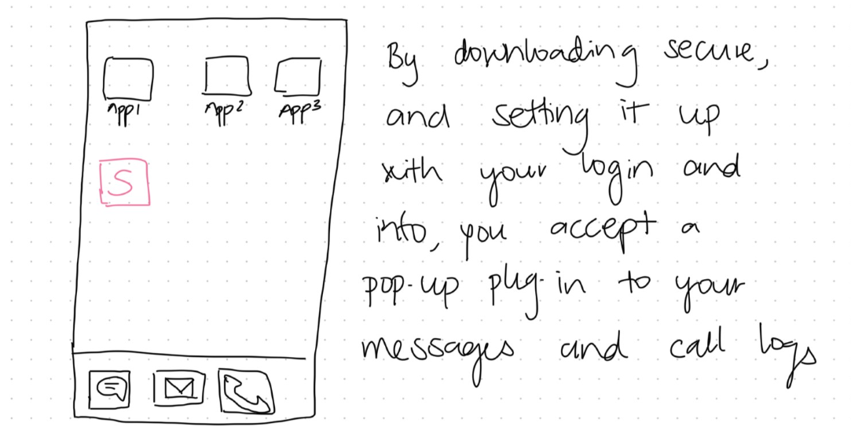

* Users have to accept Secure’s access to their messages and call logs before they can use the feature, this ensures user’s privacy is respected.

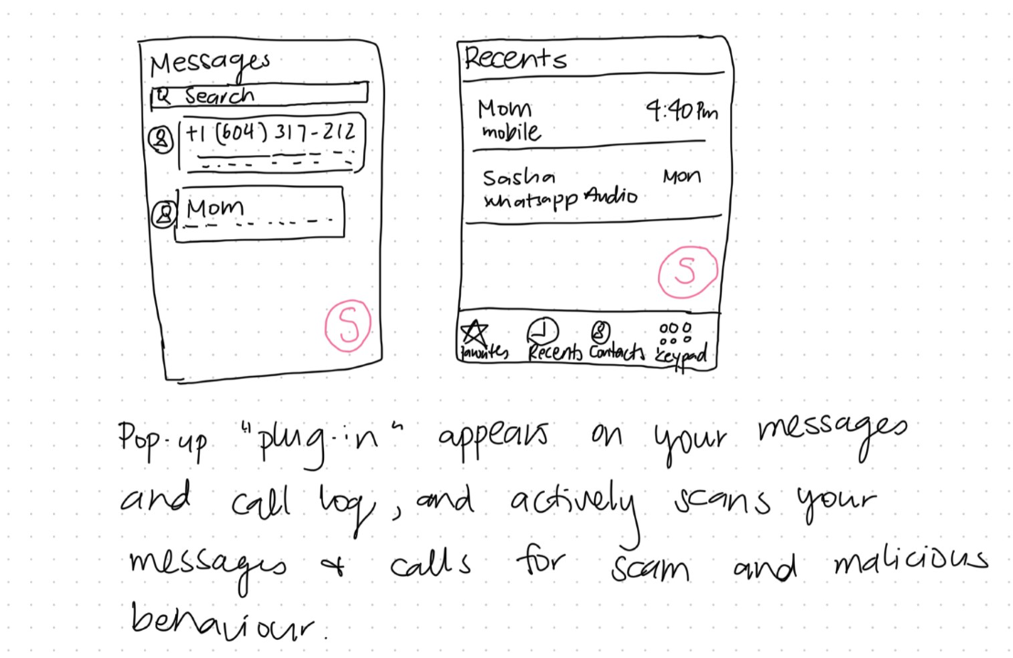

* This is what it looks like after plug in is added to messages and call log.

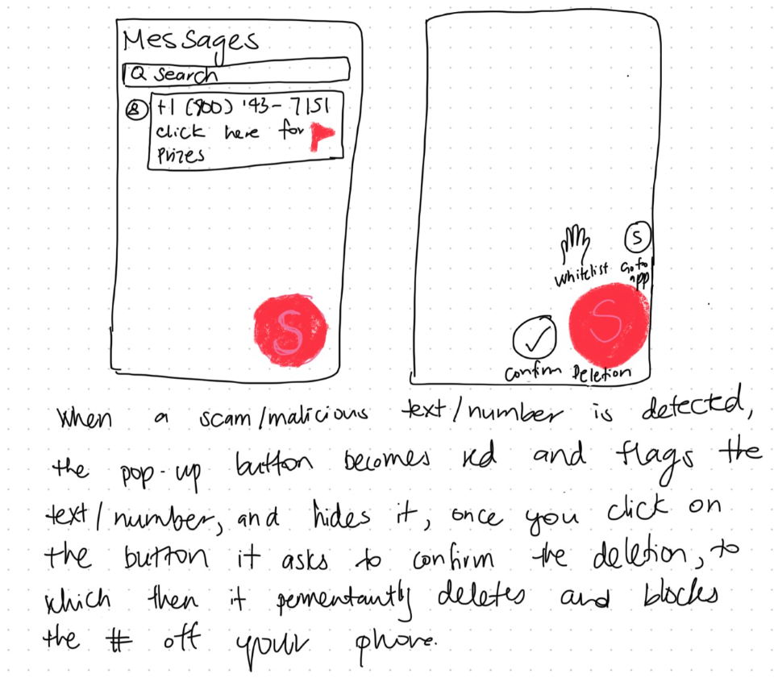

* Plug-in flags message with red flag and turns red to indicate real-time scam detection.
* Gives user the option to confirm deletion to give users control over their messages.

Context 3:Implementing real-time alerts with clear and concise messages about detected scams or suspicious activities.

